SHULL SCIENCE · JAMES A. GARFIELD LOCAL SCHOOLS
UNIT 2 QUIZ C
QUIZ · VERSION C · ELECTRON CONFIGURATIONS AND IONS
NAME | DATE | PERIOD | SCORE / 23

You may use a periodic table. For multiple choice, circle one letter. In an orbital diagram, each electron gets one arrow.

Part 1 Multiple choice | 3 points

1 | Which rule says put one electron in each box before pairing?
1 | A Aufbau principle | B Hund's rule | C Pauli exclusion | D Bohr model
2 | Which orbital diagram for carbon's 2p² follows Hund's rule?
2 | A | B | C | D
  ↑↓
  ↑ | ↓
  ↑↓
  ↑ | ↑
3 | Which sublevel fills right after 4p?
3 | A 4d | B 5p | C 4f | D 5s

Part 2 Longhand configurations and orbital diagrams | 8 points

4 | 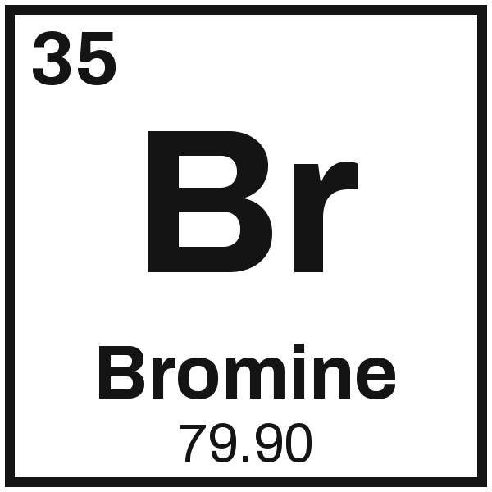 | Configuration
4 |  | Orbital diagram

5 | 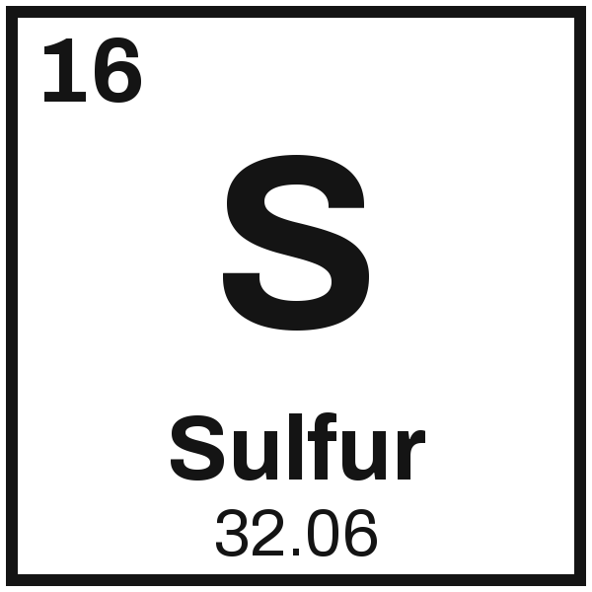 | Configuration
5 |  | Orbital diagram

Part 3 Noble-gas shorthand | 4 points

6 | 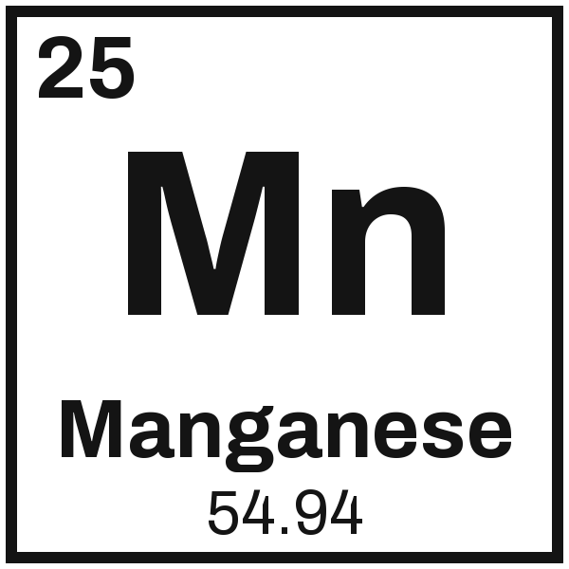 |  | 7 | 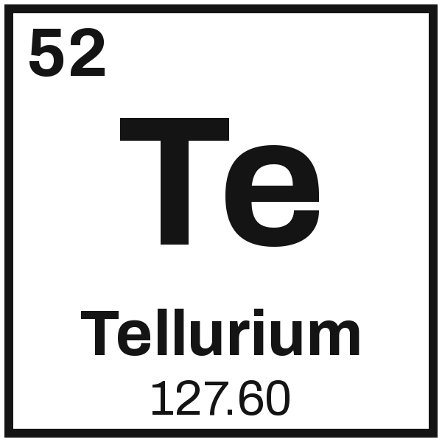

Part 4 Ions: the charge, and cation or anion | 8 points

8  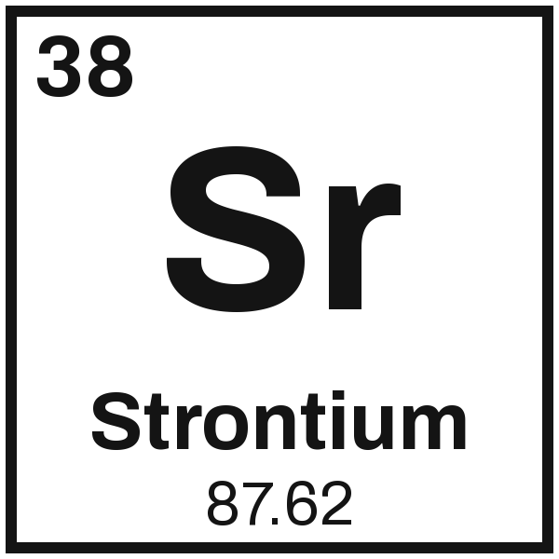  Charge _________  cation or anion | 9  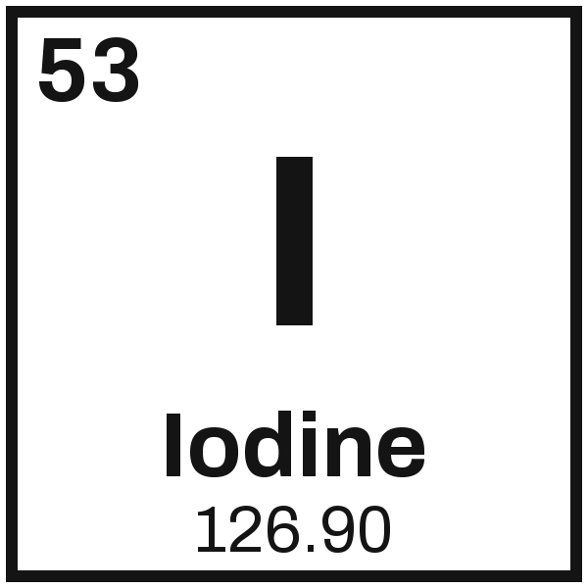  Charge _________  cation or anion | 10  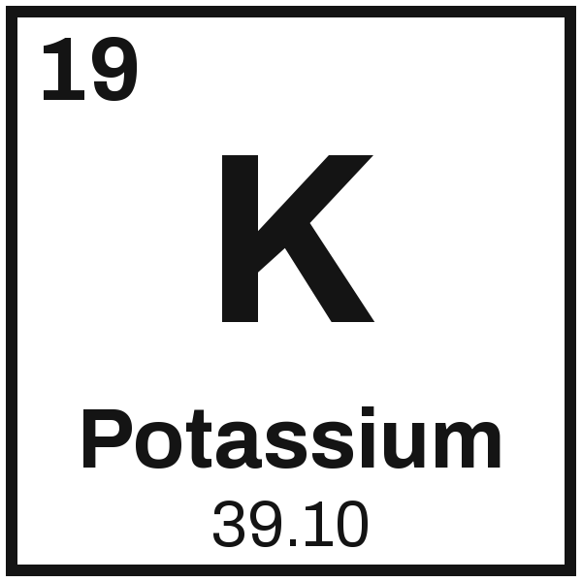  Charge _________  cation or anion | 11  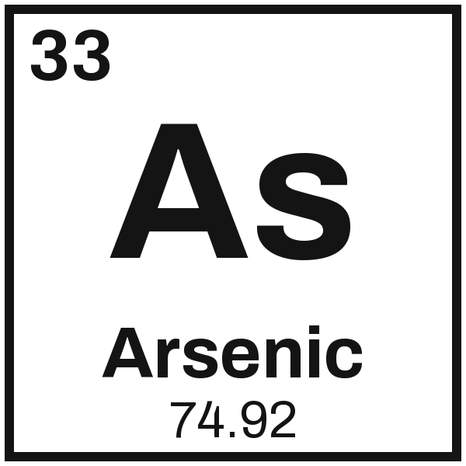  Charge _________  cation or anion

